**Assignment -3**

Digital Marketing

|  |  |
| --- | --- |
| Student Name | Angel P |
| Student Roll Number | 20URCS004 |
| NM ID | A73DA3A38A9850BBE054E48B3B0E06EB |
| College Name | AAA College of Engineering and Technology |

**QUESTION:**

**Create and design a social media advertisement poster using canva.**

**SOCIAL MEDIA ADVERTISEMENT POSTER USING CANVA:**

**Poster link:** <https://www.canva.com/design/DAFr_ophXnY/OPwTvlunQ4vQw4CQ1ThLPQ/edit?utm_content=DAFr_ophXnY&utm_campaign=designshare&utm_medium=link2&utm_source=sharebutton>

**Poster Title: Rose Buds – Baby Shop**

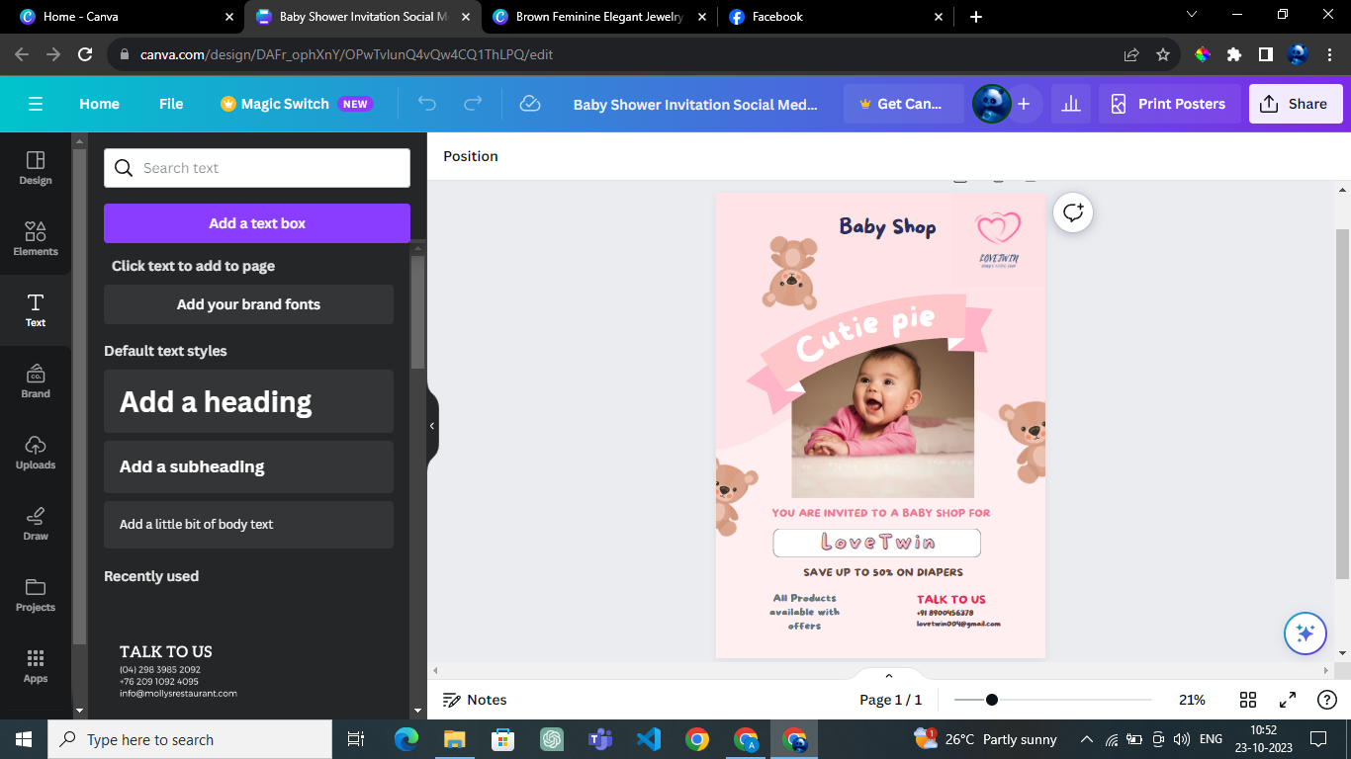

**Poster Image:**

